(Approx. 888 words)

Back to the Basics
Basic iPhone Texting
By Jim Cerny, Forum Leader, Sarasota Technology User Group, Florida
October 2017 issue, Sarasota TUG Monitor
www.thestug.org
jimcerny123 (at) aol.com

Whoever thought that “texting” would become such a common communication method? I mean, who would need to TEXT someone and spend all that time using their fingers (or thumbs) when you can just CALL the person and talk to them directly (or at least leave a voice message)?? Well, texting is indeed very popular and is found to be useful by many people. The definition of “texting” or “messaging” is using your iPhone to send text messages to another phone or device. The receiver will hear a tone that indicates a message has been received and may read it or reply to it at their leisure. This article is intended to help you with the basic texting functions. Be aware that there are more texting options and abilities beyond what is presented here.

The texting “app” (application or program) for the iPhone is called “Messages” and comes free with your iPhone. You cannot delete this app. The app logo is a white cartoon word “balloon” on a green background. Touch this app to open it for sending and reading text messages.

You can think of texting (most people use the term “texting” instead of “messaging”) as another form of email, and we all know how to use email, right? When the app is open, the starting screen will have the word “Messages” at the top center. To the left will be “Edit” and to the right will be the NEW MESSAGE icon – a square with a pencil on it. If you have any text messages on your phone you will see them listed here, the most recent message on top. You should be in the habit of DELETING text messages you no longer need, just like you do your email. There is a setting in your iPhone to set how long you wish to keep your text messages (including a “forever” option!). To DELETE a text message, touch “Edit” and an empty circle will appear next to each message sender – touch the circles of the text messages you wish to delete, and the circle will change to blue with a white check mark indicating you have SELECTED that message. Then touch on “Delete” at the bottom of the screen to delete that message.

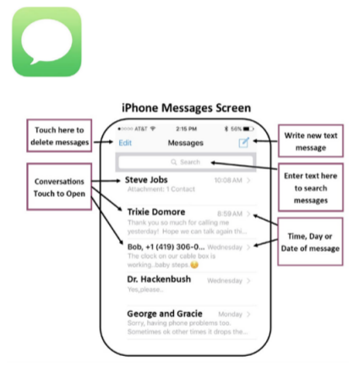
When you SEND a text message to someone and they text you in return, you are carrying on a “conversation” with that person. Your conversation of multiple messages sent and received will all be associated with that person (actually, that person’s phone number). When you delete a message, you are really deleting that conversation you had. But do not worry, when you text that person again or they text you, it begins a new conversation!
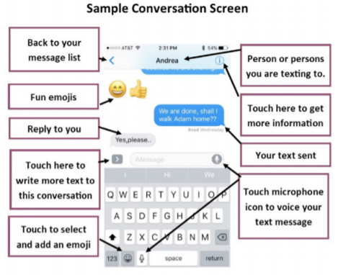

To SEND a text message, it is easiest and best if that person is in your contact list or directory. Touch the NEW MESSAGE icon (to the right of “Messages”) and you will see the “New Message” screen with your insertion point in the “To:” box at the top. Start typing in the name (the keyboard should appear on your screen) and the iPhone will look up that person in your contact list. If the person is NOT in your contact list, you will need to enter their phone number here. Remember the “To” person must have a phone that is capable of receiving text messages for your message to be sent. You can NOT text to an email address, texting is not email. Touch on the small oval area just above the keyboard display to begin entering in your text message. A text message can be any length, but why send a long message when you can CALL the person a leave a voice message?

Well, I guess it is all up to you. When you have completed your text message, touch on the GREEN CIRCLE with the up arrow in it to SEND your message. This message will be added to your message list on the home screen of “Messages”. If you change your mind and do not wish to send it, touch “Cancel”. Be POLITE and nice.

Your text messages can be kept forever and are admissible in court just like signed letters and email. When you RECEIVE a new text message you may hear a tone (which is set under “settings – sounds” on your iPhone) and the new message will appear on the “Messages” home screen. These are only the basics.

You can send and receive text messages from GROUPS or more than one person. You can send EMOJIS – those cute little symbols – to help make your text more colorful and fun. You can send and receive photos too. You must “save” the photo to your phone if you want to keep it, otherwise it will be deleted when you delete the text message.

You can also “speak” your text message by touching the microphone icon or by using Siri, you may want to try it just for fun! As always, please use Google and YouTube to view text or video instructions for texting and exploring all the options that come with it. Be sure to specify “iPhone” in your request.

Give your fingers and thumbs a workout!

